Evonik launches new UV LED curable release coatings made from recycled materials for more sustainable release liners in the label industry

- Latest innovative single-component release coating fulfils industry’s demand for sustainable solutions
- TEGO® RC 2000 LCF is compatible with less energy intensive UV LED curing and made from recycled silicone feedstocks
- Debut at Label Expo Europe 2023 in Brussels with Evonik’s other release coating solutions

Essen, Germany. Evonik is launching the first product from its new range of next generation of TEGO® RC solutions: TEGO® RC 2000 LCF. Made using recycled silicone feedstocks, the new release coating can be cured using either the less energy intensive UV LED or traditional UV Arc lamps, helping label producers lower their carbon footprint to meet growing sustainability ambitions.

According to the FINAT RADAR 2023 report, published by the European Association for the Self-Adhesive Label Industry, 81% of the members surveyed, are seeing more demand for environmentally friendly label products.

“With strong consumer demand, sustainability is increasingly at the top of the agenda throughout the entire labeling value chain,” says Chris Ogle, Global Segment Manager Release Coatings, Interface & Performance business line. “We’re focused on developing and bringing innovative solutions to market that enable our customers to meet their sustainability targets. Our latest product helps them to reduce energy consumption by adopting UV LED, and with the introduction of recycled feedstocks we’re making a major step forward in shrinking the overall footprint, without sacrificing product performance.”

Evonik’s new single component, ready to use release coating delivers easy to controlled release performance, very good curing and anchorage properties, as well as excellent aging stability with the industry’s leading pressure sensitive adhesives (PSAs) and temperature sensitive substrates.
September 4, 2023

Main press contact Leticia Jiménez Buil
Head of Market Communications Comfort & Insulation
Phone +49 201 177 3378
leticia.jimenez-buil@evonik.com

Alternative press contact Katja Marx
Head of Market Communications Specialty Additives
Phone +49 6181 59-13831
katja.marx@evonik.com

Evonik Industries AG Rellinghauser Straße 1-11
45128 Essen Germany
Phone +49 201 177-01
www.evonik.com

Supervisory Board Bernd Tönjes, Chairman Executive Board
Christian Kullmann, Chairman
Dr. Harald Schwager, Deputy Chairman Thomas Wessel, Maike Schuh

Registered Office is Essen Register Court Essen Local Court Commercial Registry B 19474

Evonik showcases the new TEGO® RC 2000 LCF and its entire release coatings portfolio for label and linerless label applications during Labelexpo Europe 2023 in Brussels, from 11 – 14 September, 2023 at booth #3C66.

To learn more about Evonik TEGO® RC Silicones, visit Evonik at Labelexpo Europe booth #3C66 or www.evonik.com/tego-rc.
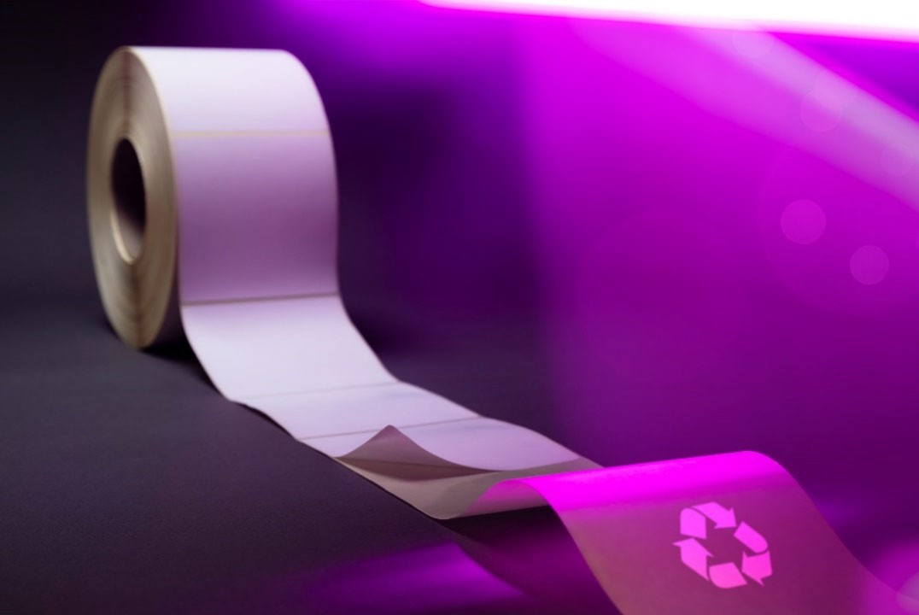

Company information
Evonik is one of the world leaders in specialty chemicals. The company is active in more than 100 countries around the world and generated sales of €18.5 billion and an operating profit (adjusted EBITDA) of €2.49 billion in 2022. Evonik goes far beyond chemistry to create innovative, profitable, and sustainable solutions for customers. About 34,000 employees work together for a common purpose: We want to improve life today and tomorrow.

About Specialty Additives
The Specialty Additives division combines the businesses of versatile additives and high-performance crosslinkers. They make end products more valuable, more durable, save more energy and simply better. As formulation experts in fast growing markets such as coatings, mobility, infrastructure and consumer goods, Specialty Additives combines a small amount with a big effect. With its 3,800 employees the division generated sales of €4.18 billion in 2022.

Disclaimer
In so far as forecasts or expectations are expressed in this press release or where our statements concern the future, these forecasts, expectations or statements

may involve known or unknown risks and uncertainties. Actual results or developments may vary, depending on changes in the operating environment. Neither Evonik Industries AG nor its group companies assume an obligation to update the forecasts, expectations or statements contained in this release.

