January 4th, 2018

Specialized Press Contact
Janusz Berger
Communication Manager
High Performance Polymers
Phone +49 2365 49-9227
janusz.berger@evonik.com

Evonik Resource Efficiency GmbH
Rellinghauser Straße 1-11
45128 Essen
Germany
Phone +49 201 177-01
Fax +49 201 177-3475
www.evonik.com

Supervisory Board
Dr. Harald Schwager, Chairman

Managing Directors
Dr. Claus Rettig, Chairman
Dr. Johannes Ohmer, Simone Hildmann, Alexandra Schwarz

Registered Office: Essen
Register Court
Essen Local Court
Commercial Registry B 25783

Evonik expands its range of base polymers

Evonik has developed a new base polymer for the plastics industry. VESTAMID® HTplus TGP3717 is distinguished by stable mechanical properties at sustained high temperatures.

The new high-temperature polymer can withstand mechanical stress up to 135°C; the glass transition temperature is 155°C. While the modulus of elasticity of a standard product falls by approximately 80% at 120°C, the decrease for Evonik’s new base polymer is only 15%. Thanks to its high crystallinity, the new plastic material has the properties typical of the VESTAMID® HTplus product range such as very good chemical resistance and dimensional stability and simple processing.

High-performance polymer as a replacement for metals
VESTAMID® HTplus from Evonik has been specially developed as a substitute for metal in classic metal applications such as highly filled molding compounds. The high-temperature stable, semicrystalline material is based on polyphthalamide (PPA).

Evonik has more than 50 years of experience in the development and production of high-performance polymers. Its extensive product portfolio covers solutions for almost every industrial application.

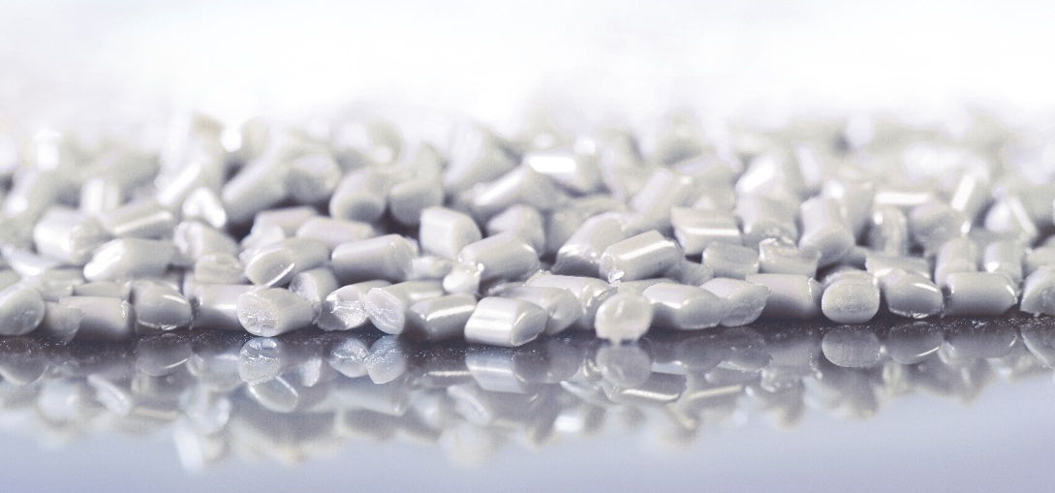
Photo caption: Evonik has developed a new base polymer for the plastics industry.

Company information
Evonik is one of the world leaders in specialty chemicals. The focus on more specialty businesses, customer-orientated innovative prowess and a trustful and performance-oriented corporate culture form the heart of Evonik’s corporate strategy. They are the lever for profitable growth and a sustained increase in the value of the company. Evonik benefits specifically from its customer proximity and leading market positions. Evonik is active in over 100 countries around the world with more than 36,000 employees. In fiscal 2016, the enterprise generated sales of around €12.7 billion and an operating profit (adjusted EBITDA) of about €2.165 billion.

About Resource Efficiency
The Resource Efficiency segment is led by Evonik Resource Efficiency GmbH and supplies high performance materials for environmentally friendly as well as energy-efficient systems to the automotive, paints & coatings, adhesives, construction, and many other industries. This segment employed about 9,000 employees, and generated sales of around €4.5 billion in 2016.

Disclaimer
In so far as forecasts or expectations are expressed in this press release or where our statements concern the future, these forecasts, expectations or statements may involve known or unknown risks and uncertainties. Actual results or developments may vary, depending on changes in the operating environment. Neither Evonik Industries AG nor its group companies assume an obligation to update the forecasts, expectations or statements contained in this release.

