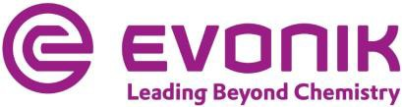

Embargoed until March 3, 2022 at 7 a.m. CET
March 3, 2022

Matthias Ruch
External Communications Phone +49 201 177 3348
Mobile +49 174 325 9942
Matthias.Ruch@evonik.com
Sheenagh Matthews External Communications Phone +49 201 177 3167
Mobile +49 152 093 87321
Sheenagh.Matthews@evonik.com

Key Financial Data: January 1 to December 31, 2021 / Outlook 2022

Sustainable and profitable: Evonik keeps growing
- Annual adjusted EBITDA rises 25 percent to €2.38 billion
- Outlook 2022: Adjusted EBITDA to increase to between
€2.5 billion and €2.6 billion
- Leadership structure: Evonik is becoming more diverse
Essen, Germany. After a very successful year in 2021, Evonik expects further growth in 2022. "We achieved really strong earnings and have consistently implemented our strategy," said Christian Kullmann, chairman of the board of management. "We are now gearing the company towards future growth. Evonik is becoming more sustainable, more profitable and more diverse."
Sales, adjusted EBITDA and free cash flow all increased more than 20 percent in 2021 compared with the previous year. Sales rose 23 percent to €15 billion on the back of continued strong demand in all the chemical divisions.
Adjusted earnings before interest, taxes, depreciation and amortization (adjusted EBITDA) were €2.38 billion, up 25 percent from the previous year. Significantly higher raw material, energy, and logistics costs were successfully offset. Adjusted net income rose 54 percent to €986 million with adjusted earnings per share gaining from €1.37 to €2.12.
Free cash flow increased 22 percent to €950 million, which corresponds to a cash conversion rate of 40 percent. "We are successfully maintaining our high cash conversion rate," said Ute Wolf, chief financial officer. "We expect free cash flow to grow for the fifth year in a row."

Page 1 of 7

Evonik Industries AG
Rellinghauser Straße 1-11
45128 Essen Germany
Phone +49 201 177-01
Fax +49 201 177-3475
www.evonik.com

Supervisory Board Bernd Tönjes, Chairman Executive Board
Christian Kullmann, Chairman
Dr. Harald Schwager, Deputy Chairman Thomas Wessel, Ute Wolf

Registered Office is Essen Register Court Essen Local Court Commercial Registry B 19474

Evonik is confident about 2022. Following a successful start, the company expects adjusted EBITDA to grow by at least 10 percent in the first quarter compared to the prior-year quarter.
For the full year, Evonik expects sales to increase to between
€15.5 billion and €16.5 billion. Adjusted EBITDA is expected to increase to between €2.5 billion and €2.6 billion. The cash conversion rate is again forecast at around 40 percent.
At the annual shareholders’ meeting on May 25, 2022, the executive and supervisory boards will be proposing to increase the annual dividend slightly to €1.17 per share. That corresponds to a dividend yield of about 4 percent.

Portfolio, Innovation
An important driver of the positive business development is Evonik's strength in innovation. In 2021, the company generated sales of more than €500 million with new products from its six innovation growth fields, up from about €350 million in the previous year. Cosmetic active ingredients and drug delivery technologies recorded particularly strong growth.
"We are well on our way to achieving our goal of generating more than €1 billion in sales by 2025 with innovative products," said Harald Schwager, the executive board member responsible for innovation. "These products are characterized by great growth potential and above-average margins."
A central driver of innovation is sustainability. This includes the goal of steadily increasing Evonik's sales of sustainable products. The share of sales from Next Generation Solutions recently rose by two percentage points to 37 percent. Next Generation Solutions are products that offer customers a clearly higher sustainability benefit compared to competing products. For example, Evonik is currently building the first industrial-scale production plant for bio-based and fully biodegradable surfactants in Slovakia.

Evonik is pressing ahead with the restructuring of its portfolio. In October 2021, for example, the company acquired the Swiss plant extract manufacturer Botanica. This strengthens Evonik's position in the market for cosmetic active ingredients. At the same time, the spin-off of the Baby Care business unit was completed in preparation for its sale.

True leadership
Evonik is initiating change in numerous management positions. Up-and-coming executives are increasingly taking on more responsibility. The proportion of women in management is rising, as is the number of managers with an international background. "The decisive factor for our success is our employees," said Kullmann. "With their expertise, creativity, and motivation, they make life a little better every day, all over the world. This diversity makes us strong and it is now increasingly reflected in the company's management positions. In short, it's the mix that counts."
This change is particularly evident at the management level below the executive board. Three of Evonik's five divisions will be headed by women, including one from the U.S. and one from France.
In addition, Evonik is strengthening its presence in Asia in terms of personnel to reflect the growing importance of the region. For the first time, a member of the extended executive board will relocate from Essen, Germany, to Asia. Claus Rettig, currently head of the Smart Materials division, will lead the entire Asian business locally with a strengthened management team and general power of attorney. "If you want to participate in the growth of the Asian markets, you can't merely supply these markets," said Kullmann. "You have to be present on the ground with modern production, research and development, and a strong management team."
The new head of the Smart Materials division will be Lauren Kjeldsen, who previously led the Specialty Additives division. She will be succeeded by Claudine Mollenkopf. Joachim Dahm will

become the new head of the Technology & Infrastructure division. Maike Schuh will become the new head of the Performance Materials division.

Development of the chemical divisions
Specialty Additives: The division's sales rose 15 percent to
€3.71 billion in 2021. Products for the construction and coating industries as well as for renewable energies achieved significant sales growth in all regions after a noticeable increase in demand. Additives for polyurethane foams for durable goods such as mattresses and refrigerators also recorded a good volume development and achieved significantly higher sales. In the second half of the year, the increase in sales was partly limited by disruptions in global supply chains and the associated lack of availability of some raw materials. Adjusted EBITDA increased
7 percent to €920 million.
Nutrition & Care: Sales at Nutrition & Care rose 19 percent to
€3.56 billion in 2021. Essential amino acids continued to be in high demand worldwide and achieved significantly higher sales with improved selling prices. At Health Care, pharmaceutical applications saw a significant increase in sales, especially lipids for mRNA vaccines. This was made possible by additional production capacities built up in the first months of the year. Care Solutions products, and in particular active ingredients for cosmetic applications, once again increased sales. Adjusted EBITDA rose 28 percent to €717 million, mainly thanks to improved selling prices.
Smart Materials: The division's sales climbed 21 percent to
€3.92 billion. Sales of polymers grew significantly. In particular, high-performance polymers recorded a significant increase in demand from the automotive industry. But demand was also strong for polyamide-12 powders for 3D printing and membranes for efficient gas processing. Sales of inorganic products also increased significantly. The tire silica business benefited from high demand worldwide, and active oxygen products were able to increase volumes in both the specialty business and the classic

hydrogen peroxide business. Adjusted EBITDA rose 23 percent to
€650 million.
Performance Materials: The division's sales improved 47 percent to €2.91 billion in 2021. Sales of C4 derivatives rose significantly on increased demand and much improved selling prices. The alcoholates business saw high demand and achieved significantly higher sales. Business development at the superabsorbent business continued to be adversely affected by the difficult market environment. Adjusted EBITDA improved from €88 million to
€317 million mainly because of higher selling prices.

 |  |  | 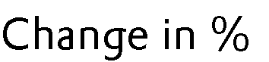
 | 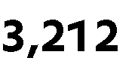 | 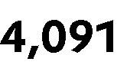 | 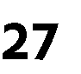 |  |  | 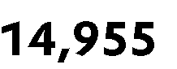
 |  |  |  |  |  | 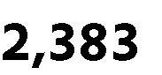 | 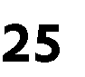
 |  |  | 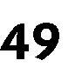 |  |  | 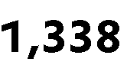
 |  |  |  |  |  | 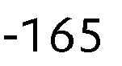
 | 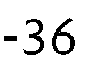 |  |  |  | 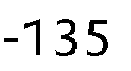 | 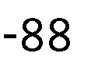
 |  |  |  |  |  | 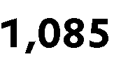
 |  | 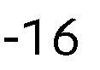 |  |  | 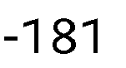
 | 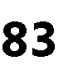 |  | 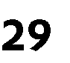 |  |  |  | 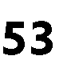
 |  |  |  |  | 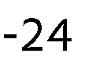
 | 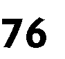 |  | 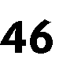 |  | 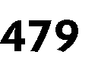
 | 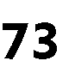 |  | 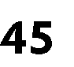
 |  |  |  |  |  |  | 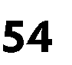

 | 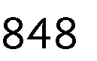 | 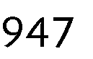 |  |  |  | 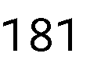
 | 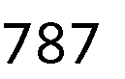 | 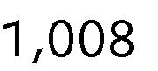 | 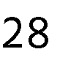 |  |  | 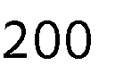 |  | 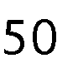
 |  | 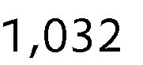 |  |  | 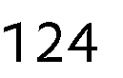
 |  | 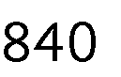 | 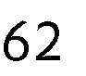 |  |  | 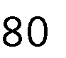 |  | 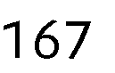
 | 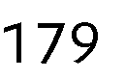 | 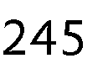 | 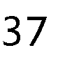 |  |  |  |  | 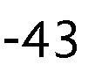
 |  |  | 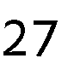

 | 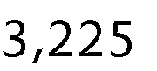 | 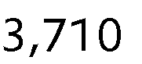 |  |  | 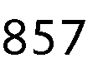
 | 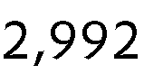 | 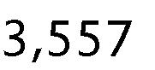
 | 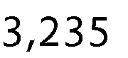 | 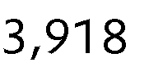 |  |  | 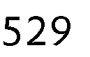 |  |  | 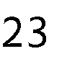
 | 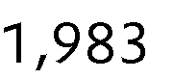 | 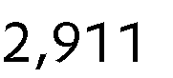 | 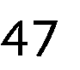 |  | 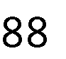 |  |  | 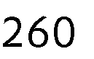
 | 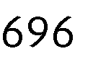 | 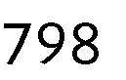 |  |  |  | 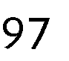 |  | 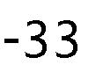
 |  | 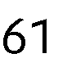 |  |  | 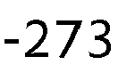 |  |  | 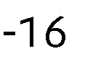

 | 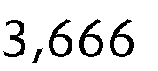 | 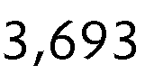
 | 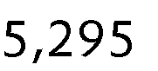 | 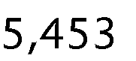
 | 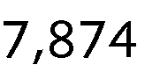 | 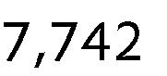
 | 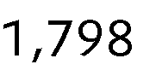 | 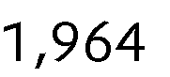
 | 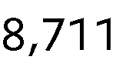 | 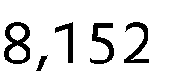
 | 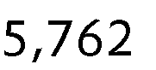 | 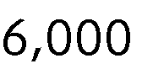
 | 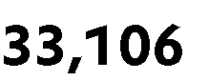 | 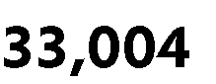

Company information
Evonik is one of the world leaders in specialty chemicals. The company is active in more than 100 countries around the world and generated sales of €15 billion and an operating profit (adjusted EBITDA) of €2.38 billion in 2021. Evonik goes far beyond chemistry to create innovative, profitable and sustainable solutions for customers. About 33,000 employees work together for a common purpose: We want to improve life today and tomorrow.
Disclaimer
In so far as forecasts or expectations are expressed in this press release or where our statements concern the future, these forecasts, expectations or statements may involve known or unknown risks and uncertainties. Actual results or developments may vary, depending on changes in the operating environment.
Neither Evonik Industries AG nor its group companies assume an obligation to update the forecasts, expectations or statements contained in this release.

