February 24, 2023

Main press contact
Janusz Berger
Head of Market Communications
High Performance Polymers
Phone +49 2365 49-9227
janusz.berger@evonik.com

Alternative press contact
Nina Peck
Head of Market Communications
Smart Materials
Phone +49 201 177-2223
nina.peck@evonik.com

Evonik Industries AG
Rellinghauser Straße 1-11
45128 Essen
Germany
Phone +49 201 177-01
www.evonik.com

Supervisory Board
Bernd Tönjes, Chairman
Executive Board
Christian Kullmann, Chairman
Dr. Harald Schwager, Deputy Chairman
Thomas Wessel, Ute Wolf

Registered Office is Essen
Register Court Essen Local Court
Commercial Registry B 19474
Evonik starts up new production plant for gas separation membranes in Austria

- Technology leadership in the global gas market
- Strong market growth in biogas upgrading, nitrogen generation or hydrogen extraction
- Driver of a sustainable gas economy as „Next Generation Solutions”

Schörfling, Austria. Evonik is driving the defossilization of the energy sector towards a sustainable gas economy: The specialty chemicals company has started up a new hollow-fibre spinning plant for the production of gas separation membranes in Schörfling am Attersee in Austria. The new production capacity enables the company to meet the continuing strong demand for SEPURAN® membranes in biogas, nitrogen, hydrogen and natural gas applications. Evonik invested a low double-digit million-euro amount in the new plant and created around 30 new jobs in Schörfling.

Technology leadership along the sustainability strategy
Lauren Kjeldsen, Head of the Smart Materials Division, says: "The growth path of the membranes business clearly follows the group's new sustainability strategy." Last May, Evonik announced plans to invest €3 billion by 2030 in Next Generation Solutions, products with superior sustainability benefits. The company's goal is to increase sales of Next Generation Solutions from the current 37 percent to more than 50 percent by 2030. The rapid increase in demand for Next Generation Solutions offers above-average growth potential for Evonik. "With our innovations, we support our customers in making their own products more sustainable and improving their own climate footprint. Our membrane technology for efficient gas separation is a living example of how Next Generation Solutions from Evonik contribute to sustainable added value in close cooperation with all market players," says Kjeldsen.

In the new production plant, a high-performance polymer is processed into fine hollow-fibres in several process steps. They are at the heart of Evonik’s SEPURAN® membrane technology. The specialty chemicals company draws on its many years of expertise in polymer chemistry and adjusts key membrane properties already at the development stage of the base material—a high-performance polymer—to produce particularly selective and robust membranes that can withstand extreme pressures and temperatures.

Driving forward sustainable gas economy
"The global gas market has confidence in our membrane technology. With the capacity expansion in Schörfling, we are sending an important signal to our customers and partners of Evonik’s commitment to helping them accelerate the energy transition towards a sustainable gas economy. We believe the energy mix of the future will be biogas, green hydrogen, and further synthesis products. That's why we are already working to expand our product portfolio and production capacities for this transformational market growth" says Dr. Goetz Baumgarten, Head of the Membranes Innovation Growth Field at Evonik.

Evonik already relies entirely on renewable energies for membrane production in Schörfling am Attersee. Green electricity from wind, water, and biomass has been a key energy source for the production facility for years. Since the beginning of 2022, the specialty chemicals company has also been meeting 100 percent of its gas requirements with biomethane from regional production. By switching to an environmentally friendly energy supply, Evonik is reducing its direct annual CO₂ emissions in Austria by around 4,000 metric tons.

From startup to technology leader within a decade
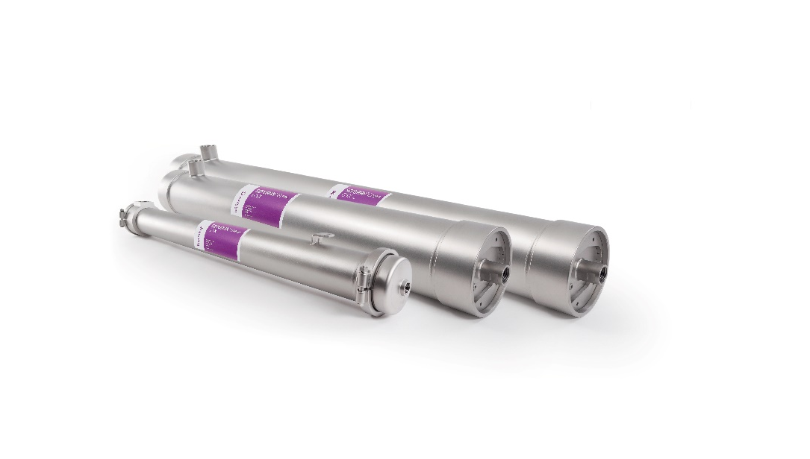
Evonik bundles its membrane activities into one of its six innovation growth fields. Within a decade, the company has become a global technology leader for gas separation membranes. SEPURAN® hollow-fibre membranes are extremely efficient for separating gases such as methane (CH₄), nitrogen (N₂), and hydrogen (H₂) from gas mixtures. The advantages of Evonik's membrane technology include a more precise separation of the gases and higher productivity. SEPURAN® N₂ membranes for efficient nitrogen generation are used, for example, for inerting airplane fuel tanks. SEPURAN® Noble membranes extract the hydrogen transported through natural gas pipelines from the CH₄/H₂ gas mixture at specific points at the H₂ gas withdrawal points. SEPURAN® NG membranes enable efficient processing of natural gas from sources with high CO₂ concentration. SEPURAN® Green membranes enable efficient biogas processing from organic and circular sources.
Image caption: SEPURAN® Green hollow-fibre membranes for efficient upgrading of biogas into high purity biomethane and Bio-CO₂. (©Evonik)

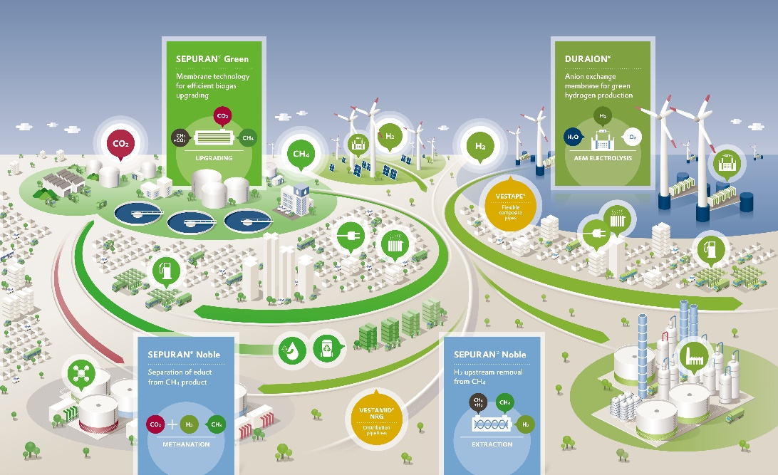

Image caption: Evonik's vision of a sustainable gas economy based on biogas and green hydrogen and their synthesis products as the main energy carriers. (©Evonik)

Company Information
Evonik is one of the world leaders in specialty chemicals. The company is active in more than 100 countries around the world and generated sales of €15 billion and an operating profit (adjusted EBITDA) of €2.38 billion in 2021. Evonik goes far beyond chemistry to create innovative, profitable and sustainable solutions for customers. About 33,000 employees work together for a common purpose: We want to improve life today and tomorrow.

About Smart Materials
The Smart Materials division includes businesses with innovative materials that enable resource-saving solutions and replace conventional materials. They are the smart answer to the major challenges of our time: environment, energy efficiency, urbanization, mobility and health. The Smart Materials division generated sales of €3.92 billion in 2021 with about 7,900 employees.

Disclaimer
In so far as forecasts or expectations are expressed in this press release or where our statements concern the future, these forecasts, expectations or statements may involve known or unknown risks and uncertainties. Actual results or developments may vary, depending on changes in the operating environment. Neither Evonik Industries AG nor its group companies assume an obligation to update the forecasts, expectations or statements contained in this release.

