May 9, 2023

Joerg Wagner
Head of External Communications
Phone +49 201 177 3408
Mobile +49 152 5638 6040
Joerg2.Wagner@evonik.com

Richard Weiss
External Communications
Phone +49 201 177 2532
Mobile +49 174 233 8658
Richard.Weiss@evonik.com

Evonik Industries AG
Rellinghauser Straße 1-11
45128 Essen
Germany
Phone +49 201 177-01
Fax +49 201 177-3475
www.evonik.com

Supervisory Board
Bernd Tönjes, Chairman
Executive Board
Christian Kullmann, Chairman
Dr. Harald Schwager, Deputy Chairman Thomas Wessel, Ute Wolf

Registered Office is Essen
Register Court Essen Local Court Commercial Registry B 19474

EMBARGO May 9, 2023, 07.00 a.m. Central European Time

Key Financial Data: January 1 to March 31, 2023

Weak economy characterizes difficult first quarter

- Adjusted EBITDA down 44 percent to €409 million
- Earnings forecast confirmed at lower end of range
- Luelsdorf site successfully sold

Essen, Germany. Despite a difficult first quarter, Evonik confirms its earnings forecast for 2023. "The start to the year was even more challenging than we feared," says Christian Kullmann, Chairman of the Executive Board. "However, we saw signs of a business recovery during the course of the first quarter. Both February and March were better than the preceding month in terms of operating profit."

The first quarter was characterized by muted economic activity and weak demand, with customers still destocking, especially in the first weeks of the new year. Overall, sales fell 11 percent to
4.0 billion euros. Volumes declined by 14 percent. Higher prices offset some of the volumes lost and compensated for inflation effects. Earnings before interest and taxes, depreciation and amortization (adjusted EBITDA) declined by 44 percent to €409 million.

Despite the weak operating results, free cash flow reached €21million. "To achieve our goals with respect to free cash flow this year, further efforts are needed," said Maike Schuh, Chief Financial Officer since April 1. "We need a lot of discipline in dealing with our working capital and investments. Now, we all have to pull together and show that we can withstand the difficult environment."

For the whole year, Evonik expects adjusted EBITDA at the lower end of the forecast range of €2.1 to €2.4 billion. The main reasons: falling prices for the animal feed additive methionine and for products of the C₄ chain.

Undeterred by the current challenges, Evonik is pressing ahead with its announced portfolio adjustments. The first step in the divestment of the Performance Materials division was the sale of the site in Luelsdorf, Germany, south of Cologne. The divestment of the Superabsorbents business is underway: Investment teasers were sent out in March, and the process is progressing according to plan.

Cost-adjustment measures including cuts in the number of external consultants, reduced business travel, and disciplined hiring are also bearing fruit. However, most of the savings target of 250 million euros will only be realized later this year.

Meanwhile, the implementation of the sustainability strategy is picking up speed. In March, Evonik started construction of a new world-scale facility for pharmaceutical lipids in the U.S. Evonik also inaugurated a corresponding production facility for clinical quantities in Hanau, Germany. In February, Evonik started up a new plant for gas separation membranes in Austria.

Development of the Chemicals Divisions

Specialty Additives: In the Specialty Additives division, revenue declined 12 percent to €921 million due to lower volumes. Selling prices were raised to pass on higher raw material and energy costs. Products for the construction and coatings industries generated noticeably lower revenue. Sales of additives for polyurethane foams and consumer durables also declined, mainly due to lower volumes. Among additives for the automotive industry, a volume decline was offset by higher selling prices, resulting in stable sales. Adjusted EBITDA at €168 million was 33 percent below the prior-year results. The adjusted EBITDA margin in the first quarter declined to 18.2 percent from 24.0 percent year-over-year.

Nutrition & Care: In the Nutrition & Care division, revenue declined by 15 percent to €886 million due to significantly lower volumes. The operating model of the Animal Nutrition business line is being adjusted, which will make the amino acids business more competitive and more profitable. The continuing decline of methionine prices illustrates the urgency of this measure. Sales in this business were down significantly. By contrast, products for the health and care industries saw higher selling prices with lower volumes, resulting in only slightly lower revenue compared to the previous year. Adjusted EBITDA declined by 66 percent to €76 million. The adjusted EBITDA margin fell from 21.4 percent in the first quarter of 2022 to 8.6 percent.

Smart Materials: Revenue in the Smart Materials division decreased by 7 percent to €1,188 million because of lower sales volumes. Selling prices rose due to the passing-on of higher raw material costs. Inorganic products saw significantly lower revenue as a result of declining demand. The higher selling prices reflect the increase in variable costs. The new capacities for the high-performance polymers PA12 created in Marl, Germany, were met with strong demand in the market. Adjusted EBITDA decreased by 23 percent to €164 million, mainly as a result of lower volumes and higher raw material costs. The adjusted EBITDA margin fell from 16.5 percent to 13.8 percent.

Performance Materials: In the Performance Materials division, revenue declined by 16 percent to €707 million. This was due to both lower volumes and prices. Products from the C₄ chain saw declining demand and falling prices, resulting in a significant drop in sales. Sales of superabsorbents increased with improved selling prices. Adjusted EBITDA decreased by 55 percent to €37 million, mainly because of the lower volumes. The adjusted EBITDA margin fell from 9.7 percent to 5.2 percent.

Excerpt from the income statement
 |  | 1st quarter
in € million |  | 2022 |  | 2023 |  | Change in %
Sales |  | 4,498 |  | 4,005 |  | -11
Adjusted EBITDA |  | 735 |  | 409 |  | -44
Adjusted EBIT |  | 472 |  | 130 |  | -72
Adjustments |  | -16 |  | -47
Financial result |  | -12 |  | -14
Income before income taxes, continuing operations |  | 444 |  | 69 |  | -84
Income taxes |  | -126 |  | -20
Income after income taxes, continuing operations |  | 318 |  | 49 |  | -85
Income after taxes, discontinued operations |  | – |  | –
Income after taxes |  | 318 |  | 49 |  | -85
thereof attributable to non-controlling interests |  | 4 |  | 2
Net Income |  | 314 |  | 47 |  | -85
Adjusted net income |  | 356 |  | 115 |  | -68

Division performance – 1st quarter
 |  | Sales |  |  |  |  |  | Adjusted EBITDA
in € million |  | 2022 |  | 2023 |  | Change in % |  | 2022 |  | 2023 |  | Change in %
Specialty Additives |  | 1,049 |  | 921 |  | -12 |  | 252 |  | 168 |  | -33
Nutrition & Care |  | 1,038 |  | 886 |  | -15 |  | 222 |  | 76 |  | -66
Smart Materialsª |  | 1,284 |  | 1,188 |  | -7 |  | 212 |  | 164 |  | -23
Performance Materialsª |  | 844 |  | 707 |  | -16 |  | 82 |  | 37 |  | -55
Technology & Infrastructure |  | 271 |  | 292 |  | 8 |  | 35 |  | 34 |  | -3
Enabling Functions, Other Activities, Consolidation |  | 12 |  | 11 |  | -8 |  | -68 |  | -70 |  | -3
Evonik Group |  | 4,498 |  | 4,005 |  | -11 |  | 735 |  | 409 |  | -44
ª Prior-year figures restated.

Employees by division
 |  | Dec. 31, 2022 |  | Mar. 31, 2023
Specialty Additives |  | 3,824 |  | 3,556
Nutrition & Care |  | 5,690 |  | 5,745
Smart Materialsª |  | 8,011 |  | 8,095
Performance Materialsª |  | 1,951 |  | 2,240
Technology & Infrastructure |  | 8,367 |  | 8,041
Enabling Functions, Other Activities, Consolidation |  | 6,186 |  | 6,241
Evonik Group |  | 34,029 |  | 33,918
ª Prior-year figures restated.

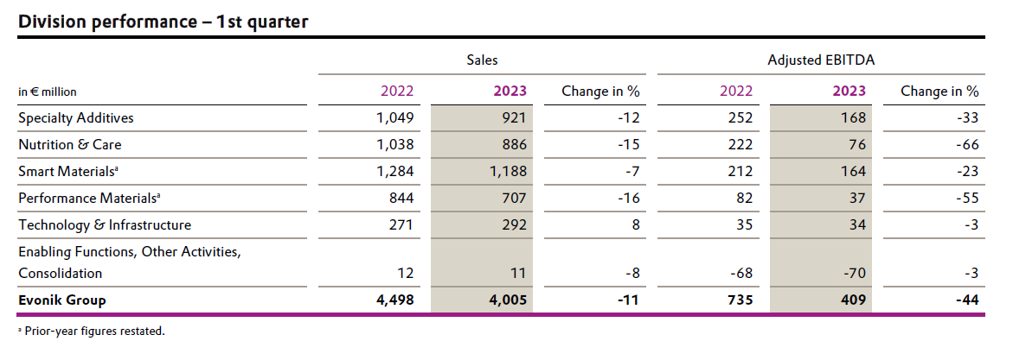

Company information
Evonik is one of the world leaders in specialty chemicals. The company is active in more than 100 countries around the world and generated sales of €18.5 billion and an operating profit (adjusted EBITDA) of €2.49 billion in 2022. Evonik goes far beyond chemistry to create innovative, profitable, and sustainable solutions for customers. About 34,000 employees work together for a common purpose: We want to improve life today and tomorrow.

DISCLAIMER
In so far as forecasts or expectations are expressed in this press release or where our statements concern the future, these forecasts, expectations or statements may involve known or unknown risks and uncertainties. Actual results or developments may vary, depending on changes in the operating environment. Neither Evonik Industries AG nor its group companies assume an obligation to update the forecasts, expectations or statements contained in this release.

