September 27, 2017

Contact specialized press
Regina Bárbara
Corporate Communication
Phone +55 11 3146-4170
regina.barbara@evonik.com
Evonik Degussa Brasil Ltda.
Rua Arq. Olavo Redig de Campos, 105
Torre A – 04711-904
São Paulo – SP - Brazil

www.evonik.com.br

facebook.com/Evonik
youtube.com/EvonikIndustries
linkedin.com/company/Evonik
twitter.com/Evonik

New brand profile for Evonik Silica

- The Silica experts get a uniform design

Since Evonik’s takeover of JM Huber’s silica business in September 2017, the global silica expert has completely redesigned the brand profile of its silica portfolio.

“By acquiring the silica business of JM Huber, we are able to offer our customers an even more diverse portfolio of products. Visually, the brand relaunch will support the broad range of product and service expertise available from a single source,” said Andreas Fischer, head of Evonik’s Silica Business Line.

The new design of the silica logo reflects Evonik’s claim of developing innovative solutions with our customers as a reliable partner. The new type and the signet give the brands a fresh, modern image and underline the ties to Evonik. Due to the family character of the new brand profile, Silica can now also present itself visually as a key pillar of Evonik’s extensive brand portfolio.

“The previous brand profile for our silica business was very heterogeneous and remained unchanged in the market for decades. We took the opportunity to update our brands’ visual design and make it more distinctive. In harmonizing the brand design, we aim to ensure that we are recognized as a full-service provider for the entire silica family. Evonik is the only manufacturer of precipitated and fumed silica,” said Dirk Schön, who works on strategic silica projects at Evonik.

The brand relaunch covers the following silica brands, among others: AEROSIL®, SIPERNAT®, ULTRASIL®, AEROXIDE®, ACEMATT® and ZEODENT®, ZEOFREE®, SPHERILEXTM, HYDREX®, and ZEOLEX®.

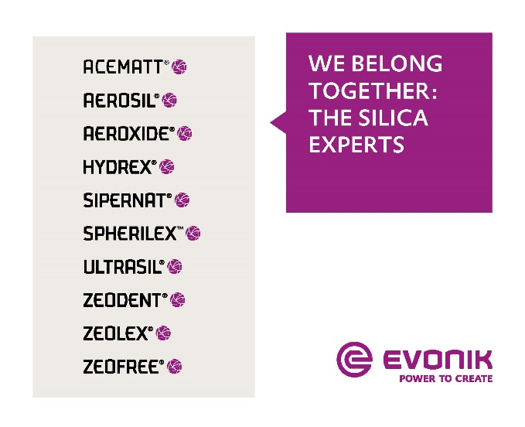

The new brand profile

Company information
Evonik is one of the world leaders in specialty chemicals. The focus on more specialty businesses, customer-orientated innovative prowess and a trustful and performance-oriented corporate culture form the heart of Evonik’s corporate strategy. They are the lever for profitable growth and a sustained increase in the value of the company. Evonik benefits specifically from its customer proximity and leading market positions. Evonik is active in over 100 countries around the world with more than 35,000 employees. In fiscal 2016, the enterprise generated sales of around €12.7 billion and an operating profit (adjusted EBITDA) of about €2.165 billion.

About Resource Efficiency
The Resource Efficiency segment is led by Evonik Resource Efficiency GmbH and supplies high performance materials for environmentally friendly as well as energy-efficient systems to the automotive, paints & coatings, adhesives, construction, and many other industries. This segment employed about 9,000 employees, and generated sales of around €4.5 billion in 2016.

Disclaimer
In so far as forecasts or expectations are expressed in this press release or where our statements concern the future, these forecasts, expectations or statements may involve known or unknown risks and uncertainties. Actual results or developments may vary, depending on changes in the operating environment. Neither Evonik Industries AG nor its group companies assume an obligation to update the forecasts, expectations or statements contained in this release.

