April 5, 2018

Specialized Press Contact
Janusz Berger
Communication Manager
High Performance Polymers
Phone +49 2365 49-9227
janusz.berger@evonik.com
Evonik Resource Efficiency GmbH
Rellinghauser Straße 1-11
45128 Essen
Phone +49 201 177-01
Fax +49 201 177-3475
www.evonik.com

Supervisory Board
Dr. Harald Schwager, Chairman Managing

Directors
Dr. Claus Rettig, Chairman
Dr. Johannes Ohmer, Simone Hildmann, Alexandra Schwarz

Registered Office: Essen
Register Court
Essen Local Court
Commercial Registry B 25783

Evonik optimizes PEEK production in China

Evonik has comprehensively optimized the production process of VESTAKEEP® PEEK and further improved the quality of the product at its Changchun, China, site. The Group is thus positioning itself as a reliable partner on the global PEEK market for the long term.

In particular, energy requirements, material use, and the waste generated during production were reduced under the optimization measures and it was simultaneously possible to boost the productivity of the PEEK plant. Evonik is thus setting new technical standards in environmental protection and safety in polyetheretherketone production.

On the product side, the innovative production process results in improved quality, such as better color characteristics.

“Our business with VESTAKEEP® high-performance polymers has been showing strong and sustained growth over several years, for example in the automotive, aviation, oil, and gas industries or the medical sector,” says Dr. Ralf Düssel, head of the High Performance Polymers Business Line. “With custom-designed and innovative products we will be able to continue serving existing markets while also opening up new ones.”

Thanks to their high heat and chemical resistance VESTAKEEP® specialty polymers can replace metal components to allow, for example, sophisticated applications in lightweight construction.

Evonik has more than 50 years of experience in the development and production of high-performance polymers. Its extensive product portfolio includes solutions for almost all industrial applications.

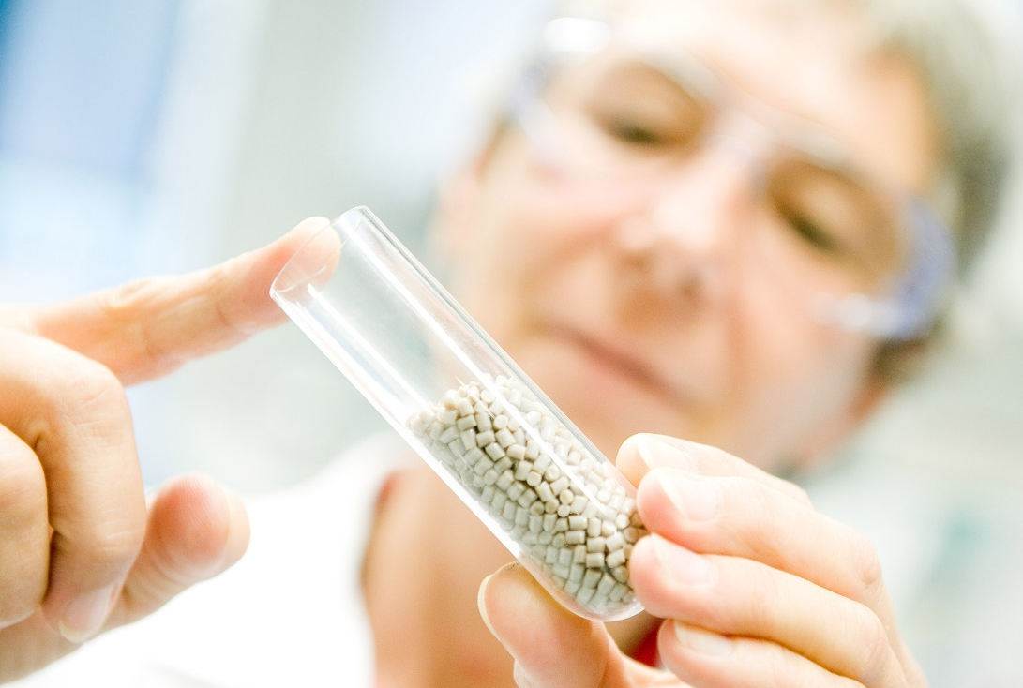

Caption: Evonik optimizes PEEK production in China.

Company information
Evonik is one of the world leaders in specialty chemicals. The focus on more specialty businesses, customer-orientated innovative prowess and a trustful and performance-oriented corporate culture form the heart of Evonik’s corporate strategy. They are the lever for profitable growth and a sustained increase in the value of the company. Evonik benefits specifically from its customer proximity and leading market positions. Evonik is active in over 100 countries around the world with more than 36,000 employees. In fiscal 2017, the enterprise generated sales of around €14.4 billion and an operating profit (adjusted EBITDA) of about €2.36 billion.

About Resource Efficiency
The Resource Efficiency segment is led by Evonik Resource Efficiency GmbH and produces high performance materials and specialty additives for environmentally friendly as well as energy-efficient systems to the automotive, paints & coatings, adhesives, construction, and many other industries. This segment employed about 10,000 employees, and generated sales of around €5.4 billion in 2017.

Disclaimer
In so far as forecasts or expectations are expressed in this press release or where our statements concern the future, these forecasts, expectations or statements may involve known or unknown risks and uncertainties. Actual results or developments may vary, depending on changes in the operating environment. Neither Evonik Industries AG nor its group companies assume an obligation to update the forecasts, expectations or statements contained in this release.

